A Small Silver Address
Description | When I was just a small niño, I used to see the small metal badges on the streets. My papa told me it would lead me to treasure if I ever found out the meaning. Now that I've met you :) Can you tell me where to go? I'm looking for the ubicación on the lower right badge.
Files | tags.jpg — one photograph, published by Portland General Electric.  Submit RCC{latitude,longitude} for the pole's mapped ground position, in decimal degrees with latitude first. Accept answers within 8 metres by distance or staff review.
Hint(s) | 1. This badge identifies a place in an inventory. It is not a manufacturing serial number.  2. PGE can mean different utilities. This tag belongs to Portland General Electric; both lines of the address matter.  3. The PGE Streetlight Viewer searches combined map-and-pole identifiers. Remove the map number's internal hyphen, then add a hyphen and the pole number.
Walkthrough | 1. Read the oval badge: PGE Co / C73-14D / 329. The Portland General Electric explanation identifies these as the map number and pole number.  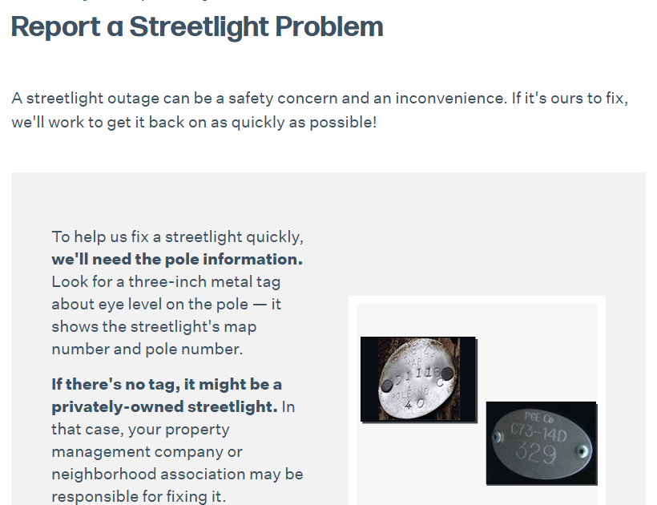  2. Open the PGE Streetlight Viewer. Its facility identifier joins the compacted map number and pole number: C7314D-329.  3. Look up that identifier in the viewer or its public Distribution Pole record. The query returns one feature. With outSR=4326, its geometry is longitude -123.01800680024955 (x) and latitude 44.958079200453454 (y).  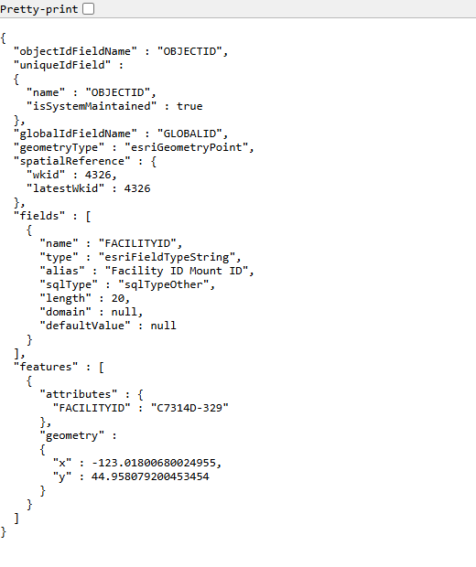  4. Put latitude before longitude: 44.958079, -123.018007, in Salem, Oregon. Submit the coordinates within the stated 8-metre tolerance.
Flag | RCC{44.958079,-123.018007}

